Motion and Force in a Gravitational Field

Test 2: Circular Motion, Universal Gravitation, Torque and Equilibrium

Name: ___________________________________________________ (32 marks]
Maximum 2 marks deducted for incorrect units and significant figures.

Time allowed: 1 hour

Outcomes covered in this test:
- explain and apply the concepts of centripetal acceleration and centripetal force, as applied to uniform circular motion—this will include applying the relationships: $a_{c}=\frac{v^{2}}{r},\text{ resultant F}=\text{ma}=\frac{{\text{mv}}^{2}}{r}$
- describe and interpret the radial gravitational field distribution around a single (point) mass
- explain and apply Newton's Law of Universal Gravitation and the concept of gravitational acceleration, g, as gravitational field strength—this will include applying the relationships: $F_{g}=G\frac{m_{1}m_{2}}{r^{2}}\text{, g}=G\frac{M}{r^{2}}$
- explain the conditions for a satellite to remain in a stable circular orbit in a gravitational field, and calculate the parameters of satellites in stable circular orbits—this will include applying the relationships:
$v_{\text{av}}=\frac{s}{t}\text{, }a_{c}=\frac{v^{2}}{r},\text{ resultant F}=\text{ma}=\frac{{\text{mv}}^{2}}{r},$$F_{g}=G\frac{m_{1}m_{2}}{r^{2}}\text{, g}=G\frac{M}{r^{2}}$.
- describe and explain the impact of satellites and associated technologies on everyday life
- explain and apply the concept of torque or moment of a force about a point, and the principle of moments, and their application to situations where the applied force is perpendicular to the lever arm - this will include applying the relationships: $τ=\text{rF}\text{ and }Στ=0$ .
- explain and apply the concept of centre of mass
- explain and apply the concept of a rigid body in equilibrium—this will include applying the relationships: $ΣF=0, τ=\text{rF}\text{ and }Στ=0$
Assume no air resistance.

- Imagine that two new planets have been discovered in another solar system, call them X and Y. They both have the same radius but planet X has twice the mass of planet Y. On the diagram below, draw in the gravitational fields for each planet. (2 marks)
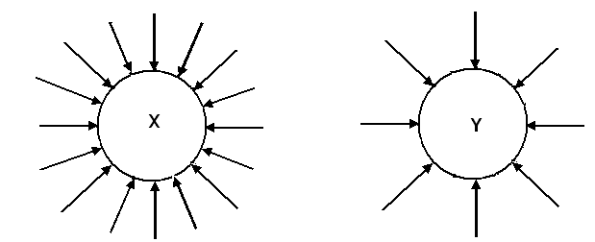
arrow correct direction – [1 mark]
twice the number of arrows on X as Y – [1 mark]

- 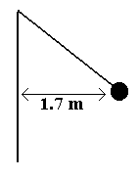A hammer thrower has gradually increased the speed of his hammer so that it completes ten revolution in 22.0 s. The hammer of mass 7.26 kg may be considered to be moving in a horizontal circle of 1.70 m radius. What force is exerted on the hammer thrower’s arm? (4 marks)

10 rev = 22 s  1 rev = 2.2 s  T = 2.2 s  r = 1.70 m  m = 7.26 kg  F_{w} = mg  = 7.26 x 9.8  = 71.148 N  [1 mark] | $$v=\frac{2πr}{T}=\frac{2xπx1\text{.}\text{70}}{2\text{.}2}$$  v = 4.8552 ms⁻¹ [1 mark]  $$F_{c}=\frac{{\text{mv}}^{2}}{r}=\frac{7\text{.}\text{26}x4\text{.}{\text{8552}}^{2}}{1\text{.}\text{70}}$$  F_{c} = 100.67 N [1 mark]  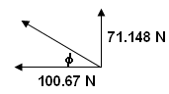  $$F_{T}=\sqrt{(\text{71}\text{.}{\text{148}}^{2}+\text{100}\text{.}{\text{67}}^{2})}$$  F_{T} = 123.27 N  φ = tan⁻¹ (71.148 ÷ 100.67)  φ = 35.3⁰  F_{T} = 101 N 35.3⁰ above horizontal  [1 mark]

- Discuss one important use for satellites that are evident in our daily lives. (2 marks)

Important use such as:
Various answers such as Communication, Meteorological satellites, TV, etc.

Evident in our lives:
Depends on answer above but a brief discussion on how evident in our lives.

- Ben. whose total mass is 1.20 x 10² kg (Ben and space suit) is on a space walk 725 km above the Earth. Assuming that the force of the nearby space ship is insignificant compared to the force of the Earth,
- What gravitational acceleration does Ben experience on his space walk? (2 marks)

$g'=\frac{6\text{.}\text{67}x{\text{10}}^{−\text{11}}x5\text{.}\text{98}x{\text{10}}^{\text{24}}}{(\text{7095000})^{2}}$m = 120 kg

r = r_{E} + r_{B}
= 6.37 x 10⁶ + 725000 g’ = 7.92 ms⁻² [1 mark]
= 7095000 m [1 mark]
m_{E} = 5.98 x 10²⁴ kg

- What gravitational force is on Ben? (2 marks)

$\begin{aligned}F_{g}=\frac{{\text{Gm}}_{E}m_{B}}{r^{2}} \\ F_{g}=\frac{6\text{.}\text{67}x{\text{10}}^{−\text{11}}x5\text{.}\text{98}x{\text{10}}^{\text{24}}x\text{120}}{(\text{7045000})^{2}}\end{aligned}$

[1 mark]

F_{g} = 951 N [1 mark]

- The mass of Jupiter is 1.90 x 10²⁷ kg and its diameter is 142 984 km. What altitude would a satellite have if its orbital speed is 3.00 x 10⁴ ms⁻¹? (3 marks)

m_{J} = 1.9 x 10²⁷ kg $F_{c}=F_{g}$
r_{T} = r_{J} + r_{s} $\frac{m_{s}v^{2}}{r}=\frac{{\text{Gm}}_{J}m_{s}}{r^{2}}$ cancel m_{s} and r
v = 3.0 x 10⁴ ms⁻¹ $r_{T}=\frac{{\text{Gm}}_{J}}{v^{2}}=\frac{6\text{.}\text{67}x{\text{10}}^{−\text{11}}x1\text{.}9x{\text{10}}^{\text{27}}}{(3\text{.}0x{\text{10}}^{4})^{2}}$ [1 mark]

r_{T} = 140811111 m
r_{s} = r_{T} - r_{J}
= 140811111 – 71492000 [1 mark]
= 69319111

altitude of satellite is 6.93 x 10⁷ m [1 mark]

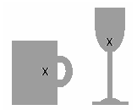
- Look at the diagrams of the wine glass and coffee mug. Mark in the centre of mass on each and then explain which is more stable and why? (3 marks)

Stability depends on position of centre of mass and area of base.
Cup has a large base area and a lower centre of mass than the wine glass. [1 mark]
It requires a much larger force to move the centre of mass outside the cup than the wine glass. [1 mark]
If a small force is applied to moved the centre of mass outside the base of the wine glass, the weight of the glass provides a torque to easily topple it over. [1 mark]

- A shopkeeper wants to hang two signs from a 10.3 kg horizontal pole fixed to the wall. The first sign has a mass of 5.20 kg and is to be hung 0.800 m from the wall. The second sign has a mass of 6.60 kg and is to be hung 0.200 m from the end of the pole. The pole is 2.00 m in length. If the fixture at the wall can withstand a torque of 2.50 x 10² Nm, will the shopkeeper need to add additional support to the pole? (3 marks)

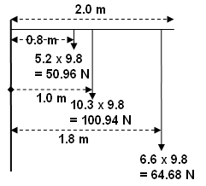
τ = (0.8 x 50.96) + (1.0 x 100.94) + (64.68 x 1.8) [1 mark]
= 40.768 + 100.94 + 116.424
= 258.132 [1 mark]

As the torque is greater than 150 Nm provided, the shopkeeper will need to add additional support.
[1 mark]

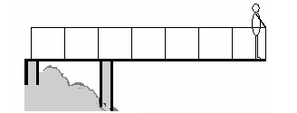
- Alan (mass 85.0 kg) is standing 0.500 m from the end of a 4.60 m viewing platform which extends out over a scenic river. The 2.30 x 10³ kg platform is support by two supports, one at the start of the platform and one 1.60 m from the start as shown. Determine the force on each support. (4 marks)

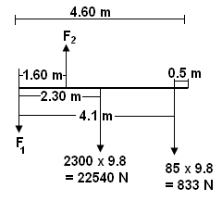
Take moments about F₁
ΣCM = ΣACM
(22540 x 2.3) + (833 x 4.1) = F₂ x 1.6
51842 + 3620.3 = 1.6F₂
55462.3 = 1.6F₂
F₂ = 34664 N

F up = F down
F₂ = F₁ + 22540 + 833
34664 = F₁ + 23373
F₁ = 11291 N

F₁ = 1.13 x 10⁴ N down [2 marks]

F₂ = 3.47 x 10⁴ N up [2 marks]

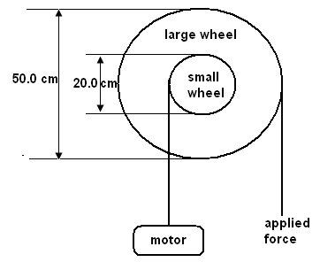
- A windlass is a simple machine that consists of two concentric wheels of different diameter than can be used to lift heavy weights. A home mechanic is using a windlass to lift a 225 kg engine out of his car. The smaller wheel of the windlass has a diameter of 20.0 cm and the larger wheel 50.0 cm. Calculate the minimum force necessary to lift the engine out of the car. (2 marks)

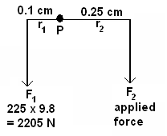

Take moments about P
ΣCM = ΣACM
F₂ x 0.25 = 2205 x 0.1 [1 mark]
F₂ = 882 N

minimum force = 882 N [1 mark]

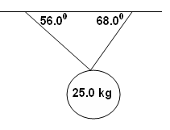
- A mirror ball hangs from the ceiling at a local nightclub. The two supporting wires have angles of 68.0⁰ and 56.0⁰ to the horizontal. The mirror ball has a mass of 25.0 kg. Calculate the tension in each wire including a diagram. (5 marks)

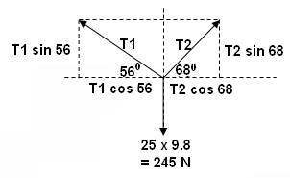

[1 mark]

Horizontal components:

T₁ cos 56 = T₂ cos 68
0.5592T₁ = 0.3746T₂
T₂ = 1.4927T₁ [1 mark]

Vertical components:

T₁ sin 56 + T₂ sin 68 = 245
but T₂ = 1.4927T₁
so
T₁ sin 56 + (1.4927T₁)sin 68 = 245 [1 mark]
0.829T₁ + 1.384T₁ = 245
2.213T₁ = 245
T₁ = 111 N [1 mark]

Resolve for T₂:

T₂ = 1.4927T₁
T₂ = 1.4927 x 110.7
= 165 N [1 mark]

T₁ = 111 N and T₂ = 165 N

